“Java Software Developer Internship at Incedo Inc.”
A Mid-term Report
Submitted in partial fulfillment of requirement of
B.E. in Information Technology

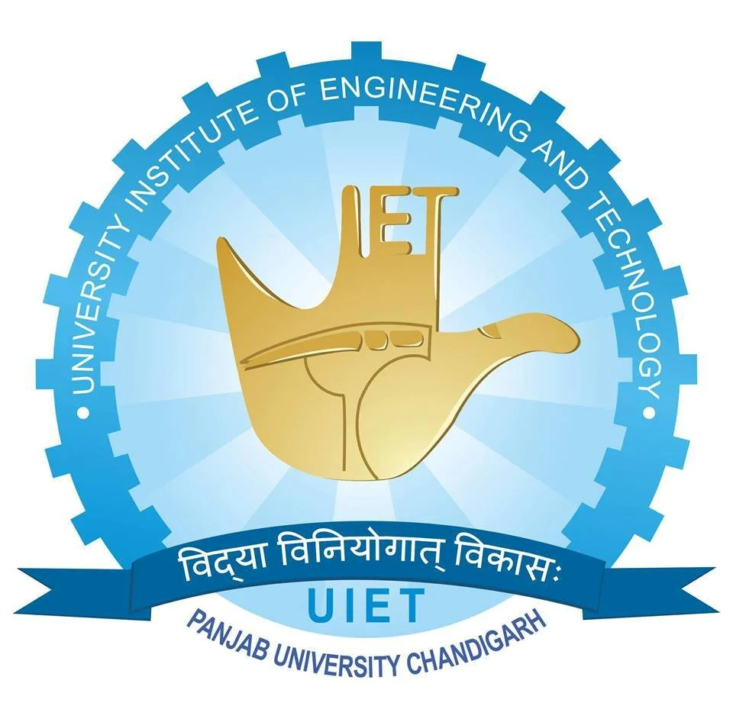

Mohd Zaid Habib
UE228071
(BE - IT 8TH SEM)

UNIVERSITY INSTITUTE OF ENGINEERING AND TECHNOLOGY
PANJAB UNIVERSITY, CHANDIGARH
2026

DECLARATION

I hereby declare that the project work entitled “Gym Management System Using Spring Boot Microservices and React” is an authentic record of my own work carried out at Incedo Inc as requirements of six months project semester for the award of degree of B.E. at University Institute of Engineering & Technology, Panjab University, Chandigarh under the guidance of Ruchi Jain and Sukesha Sharma, during ____________________.

Date: ____________________
Mohd Zaid Habib
UE228071

Certified that the above statement made by the student/trainee is correct to the best of our knowledge and belief.

Sukesha Sharma
Professor Ruchi Jain Manager
Faculty Coordinator Industry Coordinator

Acknowledgement

I would like to express my sincere gratitude to my industry mentor Rama Krishna for providing me the opportunity to work on the project “Gym Management System Using Spring Boot Microservices and React”.
I would also like to thank my faculty coordinator Dr. Sukesha Sharma for their continuous guidance and support during my internship training.
I am thankful to University Institute of Engineering and Technology, Panjab University for providing me the opportunity to undertake this internship as a part of my academic curriculum.
Finally, I would like to thank all those who directly or indirectly helped me during the completion of this work

Abstract

This report presents the work carried out during the first phase of my six-month industrial internship at Incedo Inc., from 13 January 2026 to March 2026.
The internship began with an onboarding process followed by extensive technical training in Java, Spring Boot, React, Microservices, DevOps, and AWS Cloud technologies. During this training period, I learned important software development concepts including object-oriented programming, database management, RESTful API development, containerization using Docker, and frontend development using React.
As part of the hands-on learning activities, a Gym Management System project was developed to apply full-stack development concepts and understand the architecture of enterprise applications.
In addition to technical training, I also completed domain knowledge sessions related to retail banking and financial systems, covering topics such as retail lending, payment systems, financial risk management, anti-money laundering, and financial fraud prevention.
Currently, I am undergoing Agentic AI training on AWS, where I have completed the prerequisite learning modules related to Generative AI and Agentic AI foundations.
This report summarizes the learning activities, technologies studied, domain knowledge acquired, and the progress made during the first two months of the internship.

Introduction to the Industry

Incedo Inc. is a global digital transformation and technology consulting company that focuses on data engineering, artificial intelligence, cloud computing, and digital product engineering.
The company provides technology solutions to industries such as:
- Banking and Financial Services
- Telecommunications
- Healthcare
- Retail and E-commerce
Incedo helps enterprises modernize their systems by building cloud-native, AI-powered, and data-driven applications. The company emphasizes innovation in areas such as machine learning, generative AI, cloud infrastructure, and digital platforms.
Through structured internship programs, Incedo provides students with exposure to modern software development practices, cloud technologies, and emerging AI solutions.

Work / Problem Assigned
During the internship, I was assigned to undergo structured training and practical implementation in modern full-stack software development technologies.
The key activities included:
- Learning Java programming and object-oriented design
- Developing backend applications using Spring Boot
- Building frontend applications using React
- Understanding microservices architecture
- Learning DevOps practices and containerization
- Deploying applications using AWS cloud services
- Gaining financial domain knowledge
- Learning Generative AI and Agentic AI technologies
The internship aims to develop both technical expertise and industry domain understanding.

Objectives of the Internship

- To gain practical knowledge of enterprise software development
- To learn Java full-stack development technologies
- To understand microservices architecture
- To develop applications using Spring Boot and React
- To understand cloud deployment using AWS
- To gain knowledge about financial industry domains
- To explore AI and Agentic AI technologies

Internship Timeline

Period | Activity
13 Jan – 15 Jan | Onboarding and environment setup
16 Jan – 16 Feb | Java Full Stack Development Training
17 Feb | Technical evaluation
18 Feb – 3 Mar | Domain knowledge training
4 Mar – Present | Agentic AI training on AWS

Technical Training – Java Full Stack Development
During the training phase, several core software development technologies were covered.

Java Programming
The Java training covered both basic and advanced programming concepts including:
- Java fundamentals
- Variables, data types, and operators
- Object-oriented programming
- Exception handling
- Collections framework
- Functional programming and lambda expressions
- Stream API
- Multithreading
- Date and time API

Database and ORM
The training also included database management concepts:
- Relational database architecture
- SQL queries and database design
- Data definition and data manipulation
- JDBC connectivity
- Hibernate ORM framework
- Entity relationships and mappings

Spring Framework and Spring Boot
Backend development training included:
- Dependency Injection and IoC container
- Spring Boot application development
- RESTful web services
- Exception handling
- API documentation using Swagger
- Spring Security
- JWT-based authentication

Microservices Architecture
Microservices concepts included:
- Difference between monolithic and microservices architecture
- Service discovery
- API gateway
- Inter-service communication
- Load balancing
- Configuration management
- Circuit breaker patterns

DevOps and Cloud
The DevOps training included:
- Version control using Git
- Docker containerization
- Docker Compose
- CI/CD pipeline concepts
- Deployment using AWS EC2
- Database hosting using AWS RDS

React Frontend Development
Frontend training focused on building interactive web applications using React.
Topics included:
- React components
- Props and state management
- React hooks
- Routing using React Router
- Form handling
- API communication using Axios
- Redux state management

Practice Project – Gym Management System
During the Java full stack training phase, a Gym Management System was developed as a practice project to apply the concepts learned during the training.
The purpose of this project was to simulate a real-world application for managing gym operations.
The system allows management of:
- Gym members
- Trainers
- Membership information
- Authentication and authorization

Technologies Used
Backend:
- Java
- Spring Boot
- Spring Data JPA
- Spring Security
- JWT authentication
Frontend:
- React
- Axios
- React Router
Database:
- MySQL
Deployment Tools:
- Docker
- AWS EC2
This project helped in understanding full-stack development, REST API design, and microservices architecture in a practical environment.

Domain Knowledge Training
From 18 February to 3 March, domain training sessions were conducted to introduce interns to the banking and financial services industry.
The training covered important financial concepts relevant to enterprise software systems.

Retail Lending
Retail lending refers to financial institutions providing loans to individual customers.
Common products include:
- Personal loans
- Credit cards
- Mortgages
- Lines of credit
Banks evaluate borrowers based on credit score, income, debt-to-income ratio, and repayment history to determine loan approval and interest rates.

Personal Loans and Line of Credit
A personal loan is typically an unsecured loan repaid in fixed installments over a specified time period.
A line of credit provides a pre-approved borrowing limit that allows customers to withdraw funds as needed.

Credit Cards and Mortgages
Credit cards allow customers to borrow money up to a predefined credit limit and repay it later.
Mortgages are secured loans used to purchase property, where the property itself acts as collateral.

Anti-Money Laundering (AML) and KYC
AML regulations help prevent illegal money from entering the financial system.
Financial institutions implement processes such as:
- Know Your Customer (KYC) to verify customer identity
- Customer Due Diligence (CDD) to monitor financial activities
These measures help detect suspicious transactions and prevent financial crimes.

Financial Risk Management
Financial institutions face different types of risks such as:
- Credit Risk – borrower fails to repay loan
- Operational Risk – failures in internal systems or processes
- Liquidity Risk – inability to meet short-term financial obligations
Banks use various monitoring and regulatory frameworks to manage these risks.

Payment Gateway Systems
A payment gateway enables businesses to accept digital payments securely.
It encrypts payment information and sends it to banks for authorization.
Payment gateways support:
- Credit cards
- Debit cards
- QR payments
- Mobile wallets

Financial Fraud
Financial fraud refers to deceptive practices used to gain financial benefits.
Examples include:
- Identity theft
- Credit card fraud
- Mortgage fraud
- Fake charity scams
Financial institutions use monitoring systems and regulations to detect and prevent fraud.

Agentic AI Training on AWS
From 4 March onwards, I began training in Agentic AI and Generative AI technologies using AWS.
This training follows the AWS Partner Agentic AI Advanced Learning Plan, which focuses on building intelligent AI systems capable of reasoning and performing tasks autonomously.
The learning plan includes theoretical modules, assessments, and practical labs to develop skills in designing scalable AI solutions using AWS services.

Completed Pre-Requisite Courses
Before starting the advanced agentic AI implementation modules, the following prerequisite courses were completed.

Generative AI on AWS (Technical)
This course introduced the applications and lifecycle management of generative AI models within the AWS ecosystem.
Key learning areas included:
- Identifying generative AI business opportunities
- AI model selection and economics
- Model lifecycle management
- Responsible AI practices
AWS services covered:
- Amazon Bedrock
- Amazon SageMaker
- AWS IAM

Agentic AI Essentials
This course explained the evolution from generative AI to agent-based AI systems.
Topics included:
- Autonomous AI agents
- Multi-agent systems
- Agent reliability and limitations
- Business applications of agentic AI
- AWS agentic AI architecture stack

Agentic AI Technical Foundations
This course focused on the technical implementation of AI agents using AWS.
Topics included:
- Agent architecture patterns
- Data foundation design
- AWS AI service selection
- Security and monitoring for AI systems
- Production deployment of AI agents

Current Learning Outcome
Through these courses, I have gained foundational knowledge of:
- Generative AI systems
- Autonomous AI agents
- AI architecture design
- AWS AI and machine learning services
The next phase will involve advanced hands-on implementation of agentic AI solutions.

Professional Certifications and Additional Learning
In addition to the structured training provided during the internship at Incedo Inc., I also pursued additional learning and certification courses to enhance my understanding of Artificial Intelligence and cloud technologies.
These courses helped me strengthen my knowledge of AI concepts, prompt engineering techniques, and AWS AI services, which are essential for modern AI-driven software development.

AWS Certified AI Practitioner
During the internship period, I also prepared for the AWS Certified AI Practitioner certification.
This certification focuses on foundational knowledge of Artificial Intelligence, Machine Learning, and Generative AI services within the AWS ecosystem.
The certification training covers key areas such as:
- Fundamentals of Artificial Intelligence and Machine Learning
- Generative AI concepts and applications
- AWS AI and Machine Learning services
- Responsible AI practices
- Security and governance in AI systems
Preparing for this certification helped me understand how AI models and services can be integrated into cloud-based applications to solve real-world business problems.

Prompt Engineering Course (Udemy)
I also completed a course on Prompt Engineering from the Udemy learning platform.
Prompt engineering is an important skill when working with large language models (LLMs) and generative AI systems, as it focuses on designing effective prompts to obtain accurate and useful responses from AI models.

Key concepts learned in this course include:
- Fundamentals of prompt design
- Techniques for improving AI responses
- Role prompting and structured prompts
- Chain-of-thought prompting
- Prompt optimization strategies
- Real-world applications of generative AI tools
This course helped me understand how to interact effectively with AI models and leverage generative AI tools for development, research, and automation tasks.

Challenges Faced
During the internship, some challenges were encountered:
- Understanding microservices architecture initially
- Configuring Spring Security and JWT authentication
- Managing communication between multiple services
- Deploying applications using Docker and AWS
- Learning advanced AI concepts such as agent-based systems
These challenges were overcome through continuous practice, mentorship, and documentation.

Work to be Done in Remaining Internship Period
The remaining internship period will involve:
- Advanced Agentic AI development
- Hands-on AI labs using AWS services
- Implementation of AI-powered enterprise applications
- Further improvements to full-stack application projects
- Learning advanced cloud and DevOps practices

Conclusion
The first phase of the internship at Incedo Inc. has been a valuable learning experience.
The structured training program provided exposure to Java full stack development, microservices architecture, cloud technologies, and financial industry domain knowledge.
The hands-on project and AI training helped in understanding how modern enterprise systems are designed and deployed.
The ongoing Agentic AI training on AWS is further expanding my knowledge in emerging technologies that are transforming the future of software development.
This internship is helping me develop both technical expertise and industry knowledge required for a career in software engineering and AI-driven systems.

References
- Java Official Documentation
- Spring Boot Documentation
- React Documentation
- AWS Training and Certification Materials
- Docker Documentation
- Incedo Training Resources

